First Class Booklist 2020-2021
English
Go With The Flow Cursive Handwriting Book C  CJ Fallon | 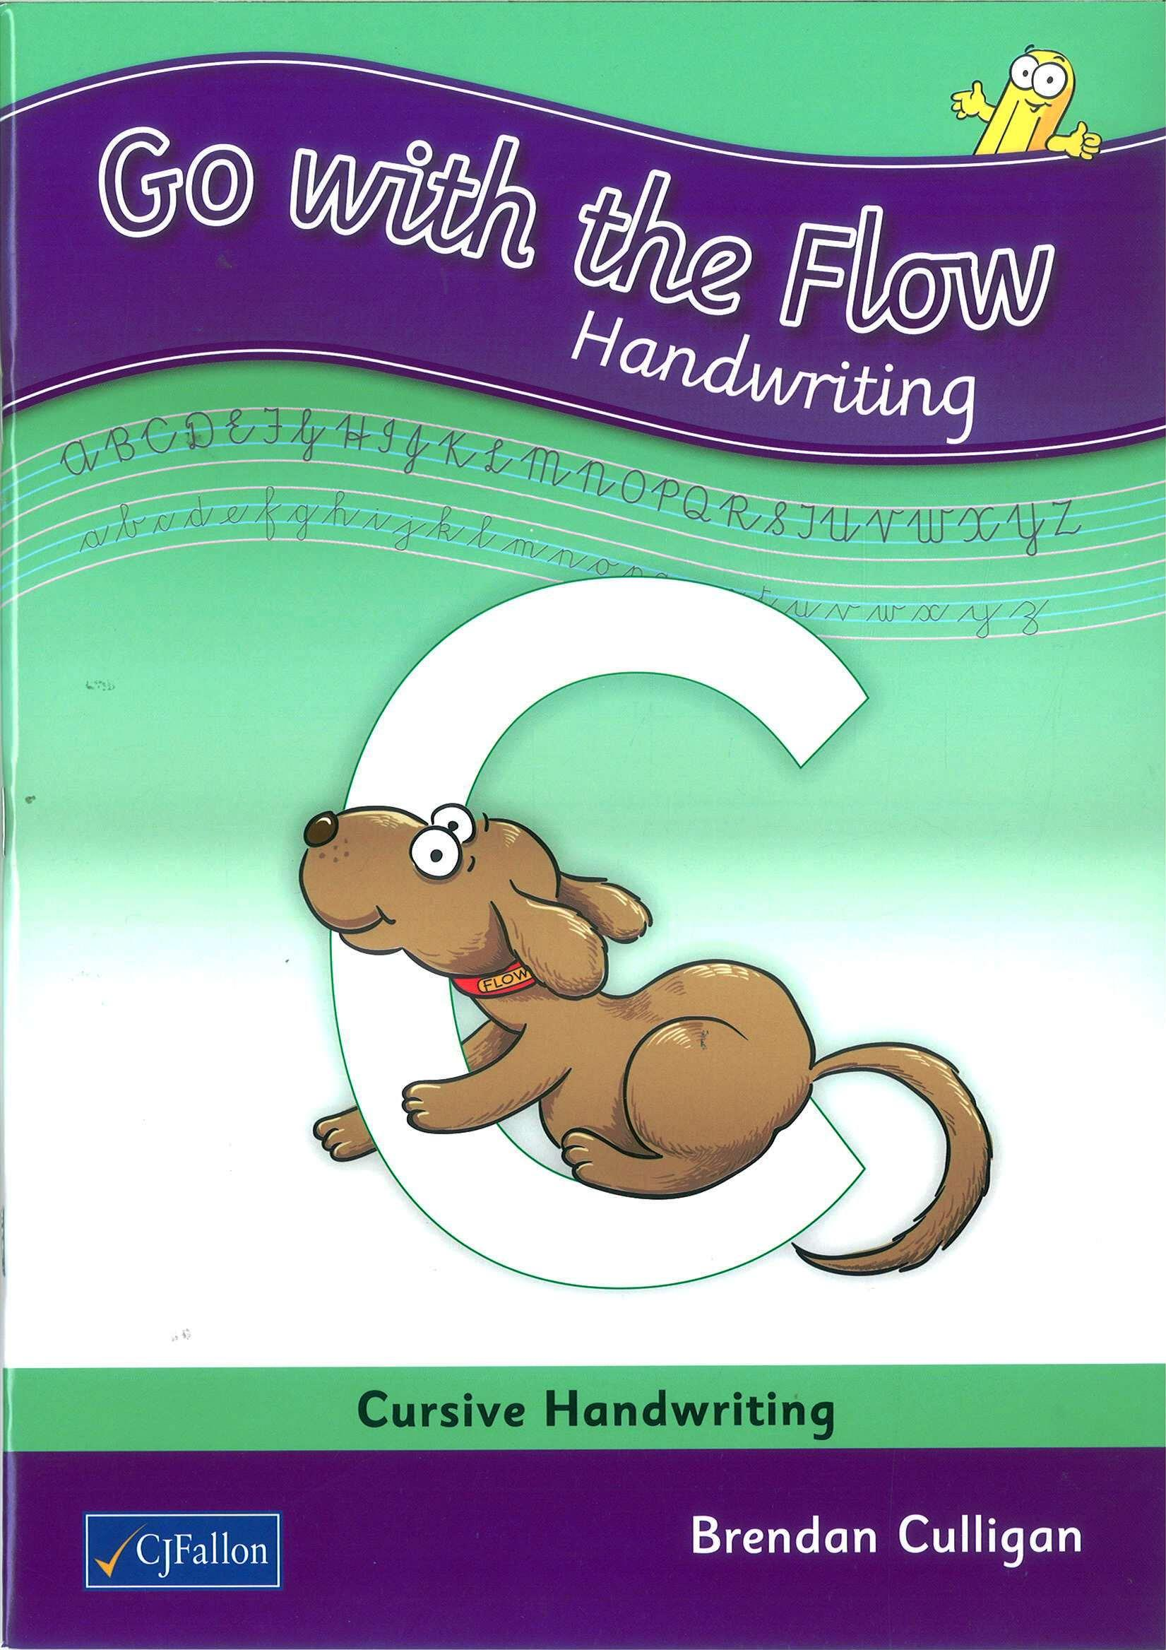
Jolly Grammer 1 Pupil Book  Jolly Learning ltd | 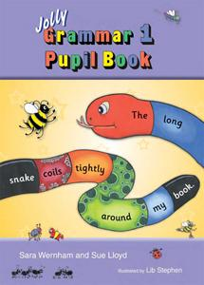
Word Wizard 1st Class  Gill Skills | 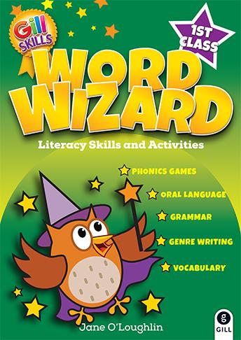
Maths
Operation Maths 1 - 1st Class Pack  (At School Book, At Home Book, Assessment Book, Mini-Whiteboard & 20 frame)  Edco | 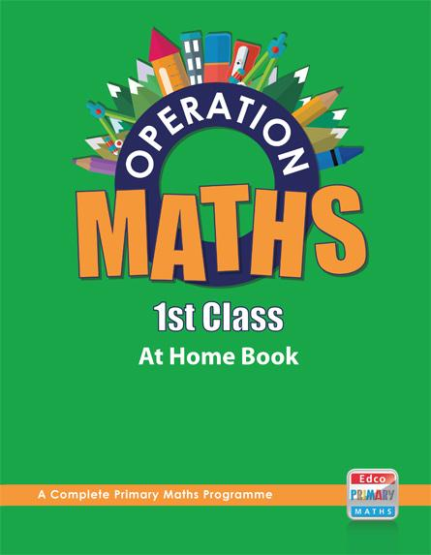
Tables Champions - Tables for First Class  Educate.ie | 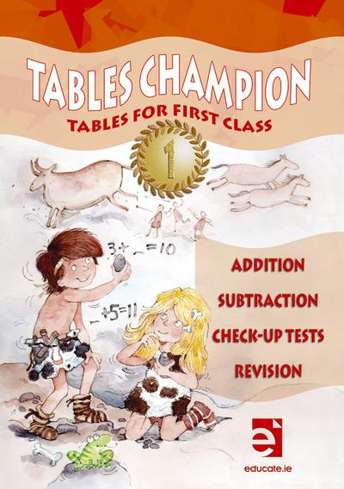

Gaeilge
Bua na Cainte  Edco | 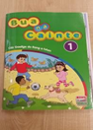
Copybooks
1 x Junior Sum Copy 2 x Exercise Copies (A11 88 pages) 5 x Project Copies(15A)
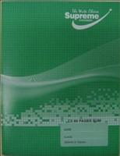
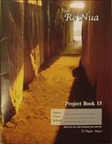
(10mm 32 pages) (Genre, Gaeilge, SESE, Spare copies)

1 x Spelling Note Book Fallon’s Homework Diary 1 x Handwriting copy.
Learn and Write B2 (32 pages)

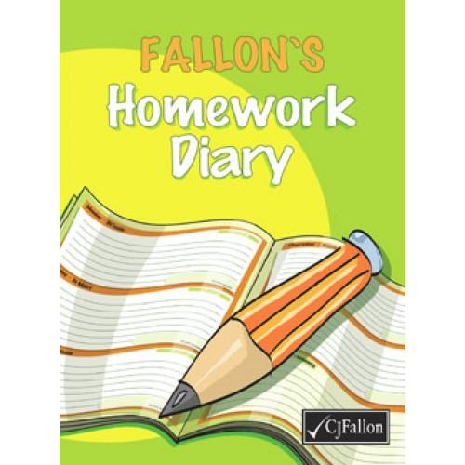
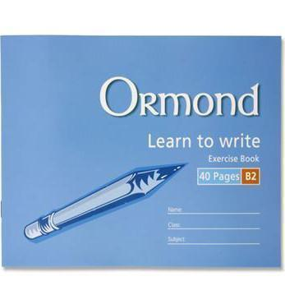

Please ensure that your child has each of the following at all times throughout the year:

5 x HB Pencils,
2 x Pencil sharpeners,
2 x Rubbers
1 x large Pritt Sticks,
5 x mini-whiteboard markers,
1 x mini-whiteboard
30cm ruler

A4 Homework folder (pouch with zip),
Pencil case

Colouring pencils (NO MARKERS),

Parents/Guardians must purchase all text book and the correct copies and stationary items.
Please cover all books and copies and put your child’s name on them.
Please ensure that your child has all of the above on the first day of school as school texts will not be photocopied
Please ensure each item of stationary is clearly labelled with your child’s name.
The school will NOT provide replacement pencils, copies, paper, rubbers, markers, Pritt Sticks for your child during the school year. Parents must replace these items.
All class booklists will be available on the school website: www.scoilchormaiccns.ie

Photographs of the books & copies & stationary are available on the school website & on the noticeboard.

The two bookshops in Balbriggan have been provided with a copy of the school booklists.

