Second Class Booklist 2020-2021
English
Word Wizard 2nd Class  Gill Education | 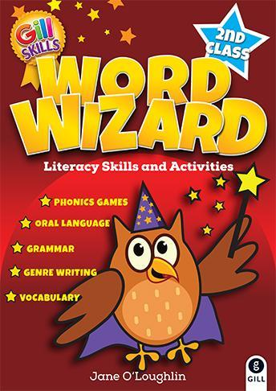
Go with the Flow Handwriting Book D  CJ Fallon | 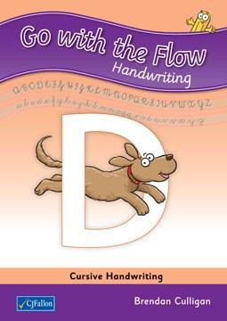
Collins Pocket English Dictionary & Thesaurus  Collins  Dictionary will be used by your child until 6th class | 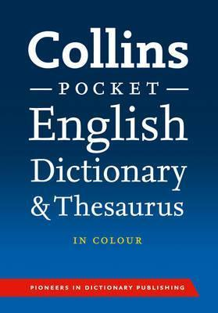
Maths
Operation Maths 2 - 2nd Class Pack  (At School Book, At Home Book, Assessment Book, Mini-Whiteboard & 20 frame)  Edco | 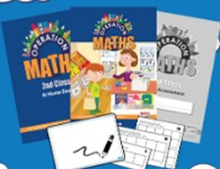
Tables Champion  Educate.ie | 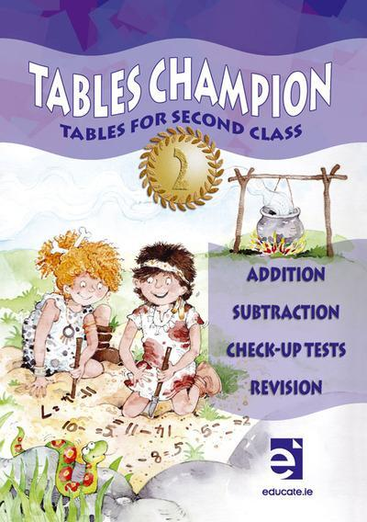

Gaeilge
Bua na Cainte 2  Edco | 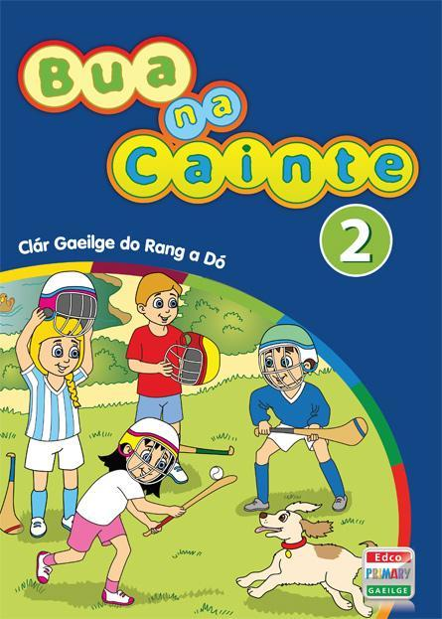
SPHE
Weaving Well-Being - 2nd Class - Character Strengths - Pupil Book  Publisher: Outside the Box | 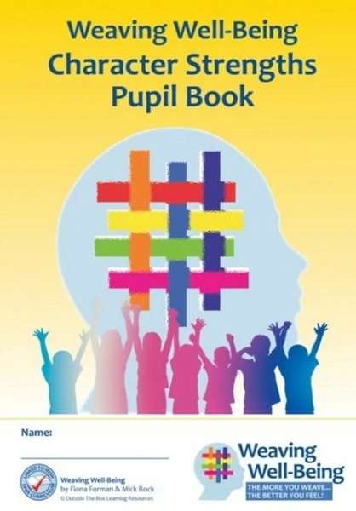
Copies and other
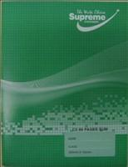
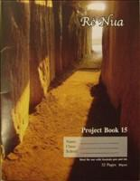
1 x Maths Copies (10mm 40pg) 3 x Exercise Copies (A11 88pg) 2 x Project Copies(15A)

(Copies for: English, Free Writing, (Copies for: SESE and
Homework) Gaeilge)

1 1 x Note Book (120pg) Tinwhistle (D)
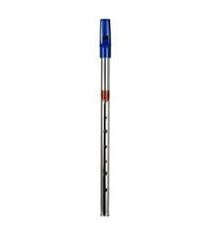

Fallon’s Homework Diary
Please note that this is the only homework diary that may be used this year.
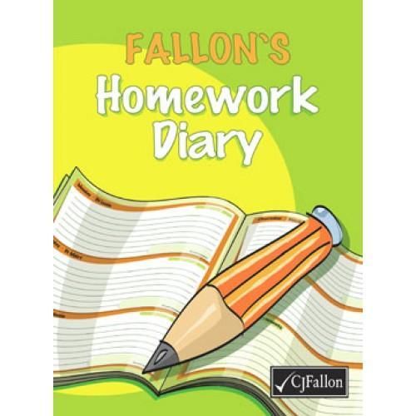

Copies and Stationary
- 1 x Maths copies (10mm squares 40 pages)
- 3 x Copybooks (A11 88 pages)
- 2x project copies (15A)
- 1 x Notebook for spellings (120pg)
- Fallon’s Homework Diary
- D Tin whistle
Please ensure that your child has each of the following at all times throughout the year:

4 x HB Pencils,
Red ballpoint pen,
Pencil sharpener,
Rubber,
30cm ruler and 15cm ruler,
Colouring pencils or crayons (NO MARKERS),
4 x large Pritt Sticks,
3 x mini-whiteboard markers (bullet tip),
Mini Whiteboard
A4 (mesh type) homework folder (pouch with zip),

Pencil case

Parents/Guardians must purchase all text book and the correct copies and stationary items.
Please cover all books and copies and put your child’s name on them.
Please ensure that your child has all of the above on the first day of school as school texts will not be photocopied
Please ensure each item of stationary is clearly labelled with your child’s name.
The school will NOT provide replacement pencils, copies, paper, rubbers, markers, Pritt Sticks for your child during the school year. Parents must replace these items.
All class booklists will be available on the school website: www.scoilchormaiccns.ie

Photographs of the books & copies & stationary are available on the school website & on the noticeboard.

The two bookshops in Balbriggan have been provided with a copy of the school booklists.

