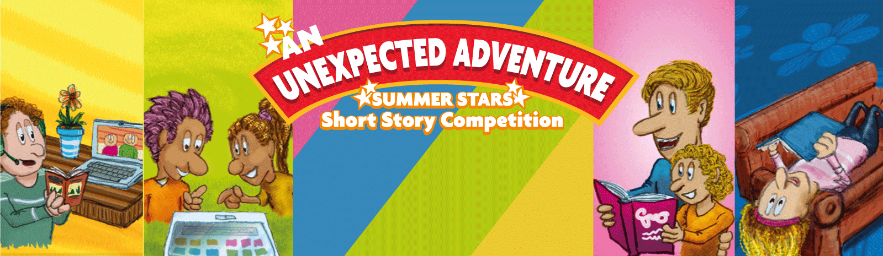

This year, as well as enjoying the all the amazing worlds you visit when reading books, Summer Stars is celebrating your imagination by running a short story competition.
Public libraries are calling on all 6-18 year olds to write a story, no more than 500 words, on An Unexpected Adventure. Of course, 6 year olds won’t be competing against teenagers! There are three age categories: age 6-9, age 10-14, age 15-18.
There will be 15 finalists in each category and one national winner from each category. Each winner will receive a Tablet and each finalist will receive a €50 voucher. That's a lot of great prizes and a lot of chances to win!
So let your imagination take you on an unexpected adventure and start writing today!

Terms & Conditions
- This competition is open to children living in Ireland.
- There are three categories: Age 6-9, Age 10-14, Age 15-18.
- Stories must relate to the theme An Unexpected Adventure.
- Stories must be no longer than 500 words.
- The competition is open for entries from 1st July to 31st August.
- Entrants can submit as many entries as they wish.
- All entries to be submitted in digital copy (e.g. Word, email or other) to summerstarsstory@lgma.ie by 5pm on 31st August. Hard copies will not be eligible.
- Entrants should include their name and age in the email. This information will only be available to the Libraries Ireland, LGMA team. This information and the competition entry itself will only be kept for the duration of the competition.
- Please use ‘Summer Stars Story’ as the subject line of the email.
- Entries must the original and unpublished work of the entrant.
- The entrant’s name should not appear anywhere in the text of the story as judging will be anonymous.
- There will be no correspondence with the judging panel and no feedback provided to individual entrants.
- There will be two rounds of judging for each category. In Round One, stories will be shortlisted and 15 will be selected to go through to the national judging final. In Round Two, a national winner will be selected from each category.
- The decision of the judges is final.
- The winning and finalist entries from each category will be uploaded to LibrariesIreland.ie and your local public library website.

